Notes: Some of the bed counts are incorrect so I changed them

Bridgeway Intensive Treatment has **20** beds (not 0)

A New Tomorrow – Kamloops Adult Treatment has **13** beds (not 20)

The Bridge Kelowna – Supportive Recovery has **8** beds (not 10)

Phoenix Centre – Kamloops Adult Withdrawal Mgmt has 20 beds (not 13)

The Bridge Kelowna Withdrawal Mgmt Royal Location (8 beds) is missing (I added it)

**Some data (tables below) not requested in the following sections** (I inserted them):

Adult SU Treatment: Bridgeway, Round Lake

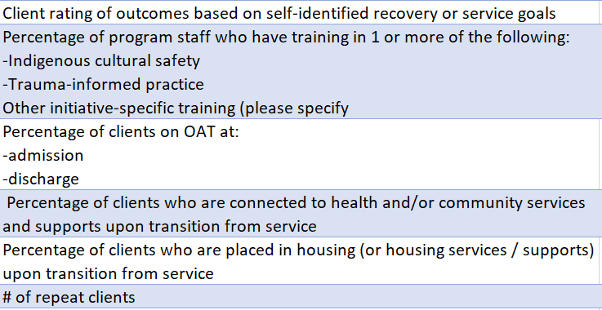

Adult SU Supportive Recovery: Bill’s Place, The Bridge Penticton, Kootenay Boundary (Nelson), ASK Wellness (Merritt), The Bridge Kelowna, ASK Wellness Kamloops, Phoenix Centre Kamloops, Round Lake, Letwilc. **Is Lillooet the only site we want this data for? I inserted them into all**

|  |  |  |  |  |
| --- | --- | --- | --- | --- |
| Client rating of outcomes based on self-identified recovery or service goals |  |  |  |  |
| Percentage of program staff who have training in 1 or more of the following:  o Indigenous Cultural Safety o Trauma-Informed Practice -Other initiative specific training (please specify) |  |  |  |  |
| Percentage of clients on OAT: -at admission -at discharge |  |  |  |  |
| Percentage of clients who are connected to health and/or community services and support upon transition of services |  |  |  |  |
| Number of repeat clients |  |  |  |  |

Adult SU Withdrawal Mgmt: Axis Castlegar, Phoenix Kamloops, The Bridge Kelowna I inserted them

|  |
| --- |
| Client rating of outcomes based on self-identified recovery or service goals |
| Percentage of program staff who have training in 1 or more of the following:   o Indigenous Cultural Safety  o Trauma-Informed Practice |
| Percentage of clients on OAT: -at admission -at discharge |
| Total number of clients who are asked to leave or transferred based on service fit |
| Percentage of clients who are connected to health and/or community services and support upon transition of services |
| Number of repeat clients |